PROJECT IN IT207
Fundamentals of Database System

ULTRABUS
TICKETING
SYSTEM

Submitted by:
Servando S. Tio III
Submitted to:
Emannuel Tumala Saligue

OUTPUT

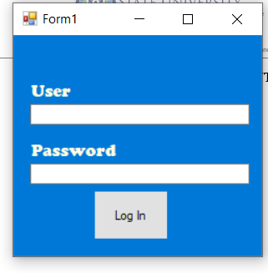

This is the User Login Interface

After logging in, this interface will be displayed
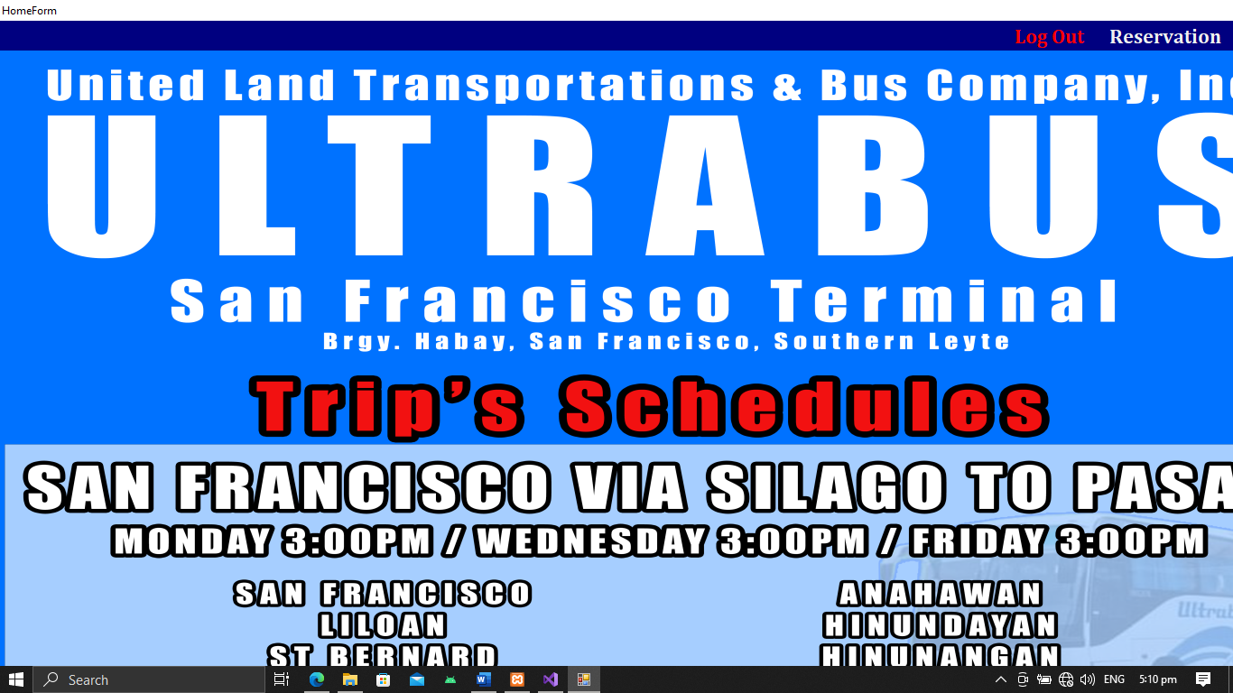

This interface serves as the Home Form.

This is the Home Form Interface

After clicking RESERVATION in the menustrip,' this interface will appear, allowing you to add a new passenger.

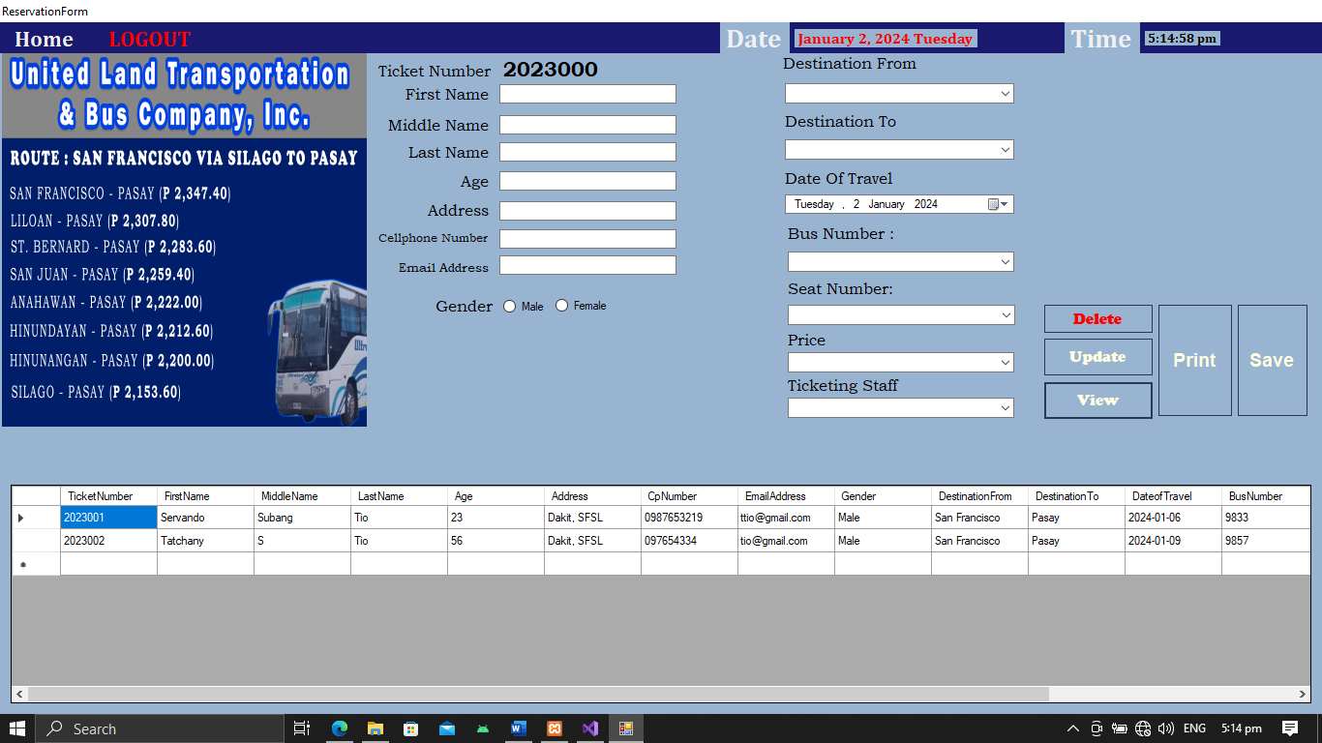

.

This is the Reservation Form Interface
This is where you enter new passengers or passengers’ details.

s

